CAMHS Connect

AT HOME WITH YOUR CHILDREN?

Stick as closely as you can to your normal routine

Schools are likely to set work for children to do at home if they’re unable to go in. Stick as closely as you can to your usual routine to keep a sense of normality. Set an alarm, have breakfast, and get them up and ready for the time they’d usually start school. Many parents have already uploaded daily schedules online so look at those examples.
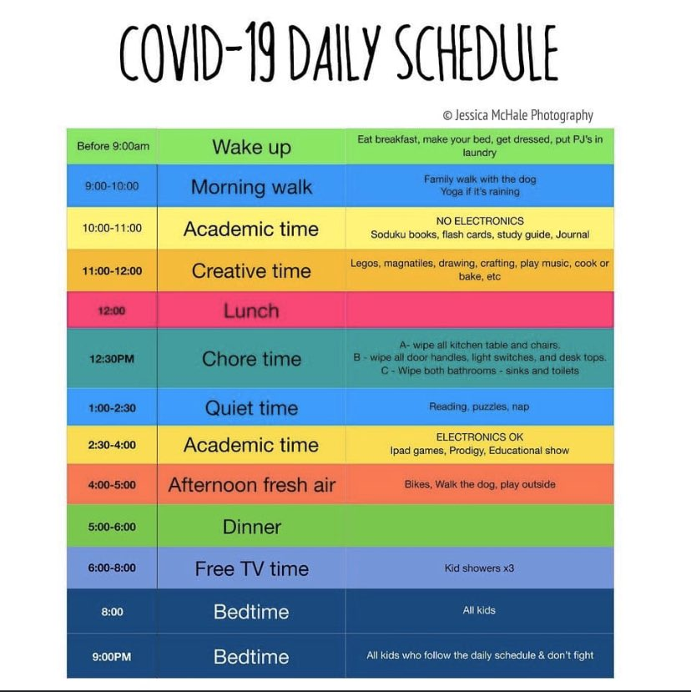
Build in breaks, recess, and lunch
Kids need breaks. Make sure to factor in down time, alone time, and outdoor play (if possible) so that kids can recharge, chill out, and have fun. It’s also a good idea to build in a lunch break where they’re not working.
Be realistic
This is an unprecedented situation, and most parents don’t have experience doing this. So give yourself a break if you don’t stick precisely to your schedule.
Make it fun
There are actually some benefits to spending all this time together. Auerbach suggests finding ways to get creative with learning, like getting kids to put on plays, teach their parents some of their favourite subjects, or put their math skills to use while cooking. Lots of things that aren’t explicitly academic can be learning opportunities, like taking a walk and looking at the trees and flowers.
Alexandra Stockwell, who homeschools her four kids, recommends taking some quarantine time to do family activities you might otherwise not have time for, like making home videos or writing letters of support to seniors living in isolation.
Keep talking to your kids
Use this extra time to talk with your kids. “Have a family chat time each day when everyone gets five to talk about how they feel,” is suggested. “It may seem odd at first, but it quickly becomes a lovely way to share feelings and bond the family together.” (Ranson, child psychologist)
Kick off the period of all being home together with a family brainstorm, to discuss ideas about how everyone would like to spend the time – both with the family and on their own.
Google ‘conversation starters with children’ for topics to talk about over meals, such as: their favourite band, what superpower they would most like to have, who they would invite to a meal if they could invite anyone, living or dead.
Bake like you’ve never baked before
Perhaps now is the time to stock up on baking items? Kids love making cakes and it’s an easy way to make treats for their time at home.
Bring out the old-school games
Revive fun pastimes like hopscotch and skipping. “They may seem old fashioned to modern kids but once they try them, they’ll get into them,” says Ranson. “Older kids can pass hours together playing the retro way.”
You could also try card games and word games or set up a ‘family disco’ and get your children to plan the playlist. Find a project you can do together, such as building a den, bird table, even clearing the garage.
Teach them life skills
Amanda Gummer, a psychologist and founder of Fundamentally Children says parents should remember a lot of skills that children need to learn aren’t taught at school. “It’s a great opportunity to teach children how to do laundry, budget to do a weekly shop, look after house plants, change a bed, sweep/vacuum the floor and so many more life skills that they will enjoy learning if you make it fun.
“Try playing match the socks when sorting laundry, or playing hunt the thimble when tidying the front room. The Goodplayguide.com has lots of fun and developmentally beneficial activities as well as educational toys and games that can help children engaged with their school subjects.”
Review screen-time rules
Experts are divided over whether you should stick to your usual screen-time rules. Ranson suggests they could be relaxed. “This isn’t the time to be strict,” she says, You could also check out the learning and academic channels on YouTube Kids. “There is a wealth of great teaching and all for free. Kids won’t realise you’ve sneaked in an extra lesson, they’ll think ‘aha, I’ve got one over on mum watching YouTube.’ But stay in the room and supervise so they don’t stray on to other content.”
See how your kids can help
Teens might be able to help older neighbours and friends who are self-isolating by doing a shop. Check who needs help in your neighbourhood and consider setting up a WhatsApp group of local families to help. Could you and your children be part of the volunteer army that helps elderly or single people who are suffering from coronavirus and deliver vital supplies to their doorstep?
Have frequent movie nights
Find ones that you can all watch, snuggled under a blanket, with some home-made popcorn.
Try and keep fit
If the weather allows, maybe go for a walk, bike-ride, or even just do some gardening with your child.
“Remember children need to exercise for at least half an hour a day. However, if it’s too cold or rainy, a pillow fight may be a good way to let off steam. Or let your child plan and run an exercise class for the family!” https://www.huffingtonpost.co.uk

For home activities and schooling visit these websites:
https://www.sparklebox.co.uk/parents/

Free printable home schooling educational resources for parents to use with their children at home.

https://www.bbc.co.uk/bitesize
There's material here for kids of all ages, from reception all the way through to A-levels. It covers every subject your kids are currently studying, and as the name suggests it's all presented in small, easily digestible chunks.
The activities and videos here are all tailored to support the National Curriculum, so you can be confident that your kids are covering the same material they would in class, with different content tailored for England, Scotland, Wales and Northern Ireland. Once they've completed a particular section, they can test their knowledge with an interactive quiz to make sure it's stuck.
https://www.bbc.co.uk/teach/live-lessons
There are lots of excellent learning resources available on YouTube, but separating the gems from the junk can be a huge task. With BBC Teach, you can be confident that every video your kids watch is well made and worthwhile. Forget the old BBC Schools programmes you might remember from your childhood (when the teacher would wheel out the old CRT TV on a trolley) – things have come a long way.
There are tie-ins with BBC series like Doctor Who, Springwatch and Blue Planet, and many of the videos are hosted by well-known BBC presenters who are skilled in holdings kids' attention and making even complex topics fun and accessible.
https://www.khanacademy.org/
Khan Academy is a US-based site, and is structured around the American school system, but it's packed with a huge amount of content that crosses over with the National Curriculum in the UK.
The arts and humanities content is quite different to what your kids would be taught in their own classrooms, but science and maths travels well, and the material on algebra, trigonometry and calculus are particularly good (especially if you're a little rusty yourself).
All content on Khan Academy is free to use, though it's a good idea to sign up for a free account so your kids can keep track of their progress. There are also mobile apps available for iPhone and Android, which they may prefer to the desktop site.

https://artfulparent.com/
Learning at home doesn't have to be all about staying in front of a screen; The Artful Parent is a site packed with fun craft ideas to get your kids thinking creatively. Many of them are well suited to younger children, and are fantastic if your little ones are starting to get bored or anxious.
Whether it's observational drawing, making sculptures from leaves or making your own playdough, each project includes a list of materials, ways to gently engage your child, and suggestions for follow-up activities.
There's also advice on how to encourage creativity and confidence – skills that will serve them well in all their academic subjects – and ways to encourage them if they're reluctant to start.

Other useful home schooling resources
- 3D Geography: printable paper templates for learning about geography
- KM Tuition: printable worksheets and past exam papers
- GamED Academy: learning through Minecraft (for a subscription fee)
- Code Studio: computer science activities and lessons

